**tpla Ma;T**

**ngah;: nry;tuj;jpdk; ju;rd;**

**fpuhkk; : J/83 nfhl;lb**

**jfty; jpul;Lgbt ,y : 41620**

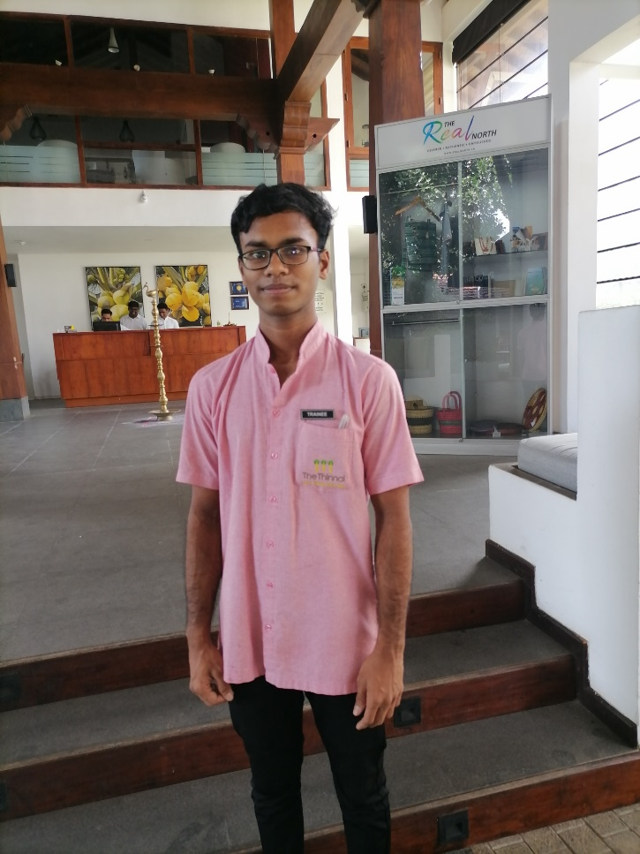

ju;rDk; mtuJ FLk;gj;jpdUk; 2007 ,y; ehl;bd; mrhjhuz #o;epiy fhuzkhf mfjpahf ,e;jpah nrd;Ws;shu;. mq;F Njhg;Gf;nfhy;iy Kfhkpy; gjptpid Nkw;nfhz;L trpj;J te;jhh;. ehl;bd; epyik rw;W rhjfkhf Njhd;wpaikahy; 2020 ,y; ehL jpUk;gpAs;sdu;.

,tu;fs;; jkJ nrhe;j Cuhd fw;FstPjp> nfhl;lb> aho;g;ghzk; vd;Dk; Kfthpapy; cwtpdu; tPl;by; jq;fpdh;. ,th;fSldhd ,y;yj; jhprpg;G Nkw;nfhz;L jfty; jpul;Lk; gbtk; G+h;j;jp nra;ag;gl;lJ. (,y.41620) FLk;g ml;il gjpT nra;tjw;F topfhl;lg;gl;lJ.

,th;fs; 2020y; ,e;jpahtpy; ,Ue;J jhafk; jpUk;Gk; NghJ jh;rd; Mary matriculation higher Secondary School ,y; 10k; tFg;gpy; fy;tp fw;Wf;nfhz;L ,Uf;Fk; NghNj ,ilapy; jhafk; jpUk;gpaikahy; ghlrhiyapy; Nru;g;gJ kpFe;j rthyhf mike;jJ. xgu; epWtdj;jpd; fsg;gzpahsupd; Kaw;rpapdhy; ju;rid Gdpj gj;jpuprpahu; fy;Yhupapy; juk; 10 ,y; Nru;j;J tplg;gl;;lhu;. ju;rDf;F .ghlrhiy cgfuzq;fs; ,izg;G nraw;ghL %yk; khtl;l nrayfj;jplk; ,Ue;J ngw;Wf;nfhLf;fg;gl;lJ.

,tu;fs; jkJ nrhe;jf; fhzpapy; rpW nfhl;lif mikj;J trpj;J te;jdu;. miuepue;ju tPL Nfhup xgu;epWtdj;jhy; toq;fg;gl;Ls;sJ. mjpy; ghJfhg;ghf trpj;JtUfpd;wdu;. jw;NghJ murhq;fj;jhy; epue;ju tPL toq;fg;gl;L jpl;lj;jpw;F Vw;g fl;Lkhdg; gzpfs; epiwtile;Js;sd. Nkyjpf Ntiyfs; nra;a Ntz;ba epiyapy; cs;sd. ju;rdpd; je;ij ,e;jpahtpy; Nkw;nfhz;l tho;thjhu njhopyhd ijay; njhopiy njhlu;tjw;Fupa ijay; ,ae;jpuk; kw;Wk; cgfuzq;fs; tho;thjhu cjtpahf jpl;lj;jpy; toq;fg;gl;lJ. mjd; %yk; jkJ tho;thjhuj;ij <l;b tUfpd;whu;.

nfhtpl; jhf;fj;jhy; ehL Kbf;fg;gl;bUe;j NghJ ghlrhiyfs; %lg;gl;ld. ,jdhy; ju;rdpd; fy;tpapy; NkYk; gpd;dilT Vw;gl;lJ. ghlrhiy Muk;gpj;jJk; tFg;gpy; rf khztid Nghd;W fy;tp fw;f Kbahky; kd uPjpapy; jho;T kdg;ghq;F cUthfp ghlrhiyf;F xOq;fhf nry;yhky; 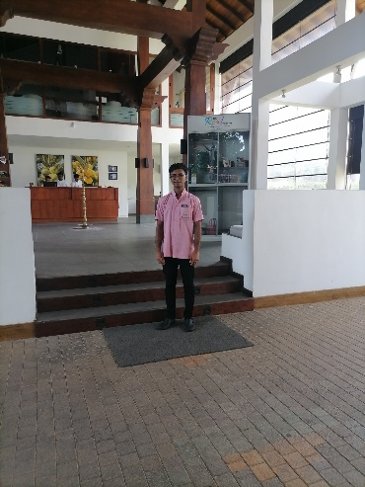 ,iltpyfp tPl;bNy ,Ue;jhh;.; fstp[aj;jpd; NghJ ju;rdpd; ngw;Nwhu; kpFe;j ftiyAld; njuptpj;jdu;. mjd; gpd; ju;rid Mw;Wg;gLj;jy; Nkw;nfhz;L ghlrhiyapYk; fijj;J ghlrhiyf;F nrd;W fw;gjw;Fupa #o;epiyia Vw;gLj;jg;gl;lJ. NkYk; Ntyizapy;; ,e;jpahtpy; ,Ue;J jhafk; jpUk;gpa gps;isfs; mjpfkhf fy;tpfw;Fk; Be Kits fy;tp epiyaj;jpy; flikahw;Wk; MrpupaUld; ju;rdpd;; fy;tp epiy njhlu;ghf fijj;J ju;rid mt; ,lj;jpw;F mioj;J nrd;W jhafk; jpUk;gpa khztu;fSld; gofp tpisahLtjw;Fupa re;ju;g;gk; mikj;Jf; nfhLf;fg;gl;lJ. f.ngh.j rhjhuzju guPl;irf;F Njhw;w itg;gjw;fhd mwpTiufs; toq;fg;gl;lJ. f.ngh.j rhjhuz ju guPl;irapy; Njhw;Wtjhf ek;gpf;ifA+l;bdhu;. mjd; gpd;ghlrhiyf;F xOq;fhf nrd;W f.ngh.j rhjhuz juk; guPl;irf;F Njhw;wpAs;shu;.

guPl;irf;F Njhw;wpa gpd; tPl;bNy ,Ue;jikahy; SoS epWtdj;jpy; eilngWk; NVQ-3 Level fw;if newpf;F ,izg;G nra;ag;gl;L tuNtw;ghsu; fw;if newpia 06 khjq;fs; G+u;j;jp nra;J 06 khjq;fs; gapw;rpf;fhf Thinnai Hotel ,y; Weightier Mf gzpGupe;J tUfpd;whu;. jw;NghJ 03 khjq;fs; epiwtile;Js;sd.

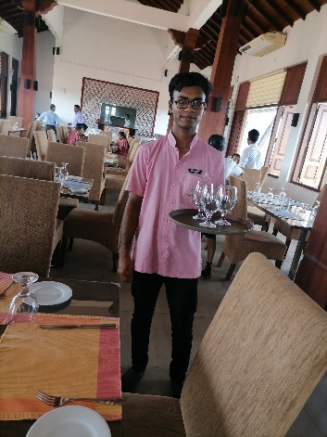

gapw;rpd; NghJ rk;gskhf 26000 &ghTk; Nkyjpf nfhLg;gdthf 10000 – 15000 tiu ngWfpd;whu;. gzpGupAk; NghJ czTNtisfspy; ,ytrkhf czT toq;fg;gLfpd;wJ. jw;NghJ gzpGupAk; ,lj;jpy; fstp[ak; Nkw;nfhz;L ju;rid re;jpj;jNghJ mtUila elj;ijapYk; Kfj;jpYk; khw;wj;ij fhzf;$bajhf ,Ue;jJ. Kd;G mjpfkhf Ngrkhl;lu;. gae;j Rghtj;Jld; fhzg;gl;lhu;. jw;NghJ jhk; Ntiy nra;Ak; ,lj;jpw;F Vw;wtifapy; jk;ik khw;wpAs;shu;.

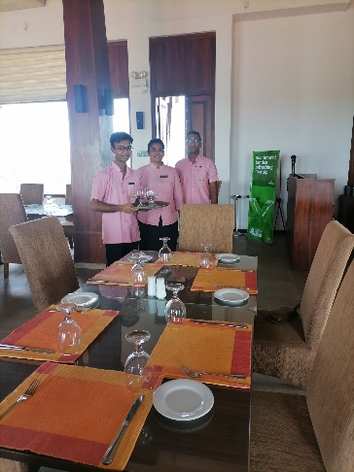 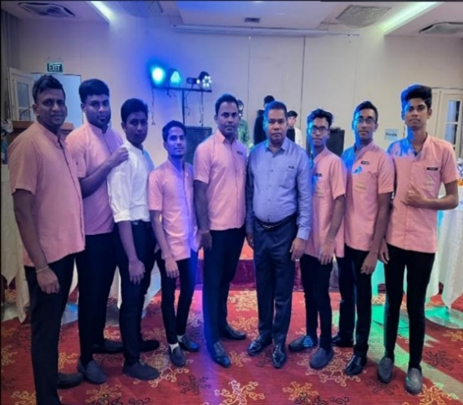

ju;rdpd; tPl;bw;F fstp[ak; Nkw;nfhz;l NghJ mtuJ FLk;gj;jpdu; ju;rid gw;wp cau;thf $Wfpd;wikiaAk; kfpo;rpiaAk; fhz Kbfpd;wJ. ju;rd; gapw;rpKbe;jJk;> NVQ rhd;wpjo; ngw;w gpd;du;; ntspehl;bw;F> Ntiy tha;g;gpw;fhf nry;Yk; Nehf;fpy; cs;shu;. vk;khy; Nkw;nfhs;sg;gl;l ,r; nraw;ghL ju;rdpd; tho;ifapy; khw;wj;ij Vw;gLj;jp cs;sikia mtjhdpf;f Kbfpd;wJ.

 "To live a creative life, we must lose our fear of being wrong."